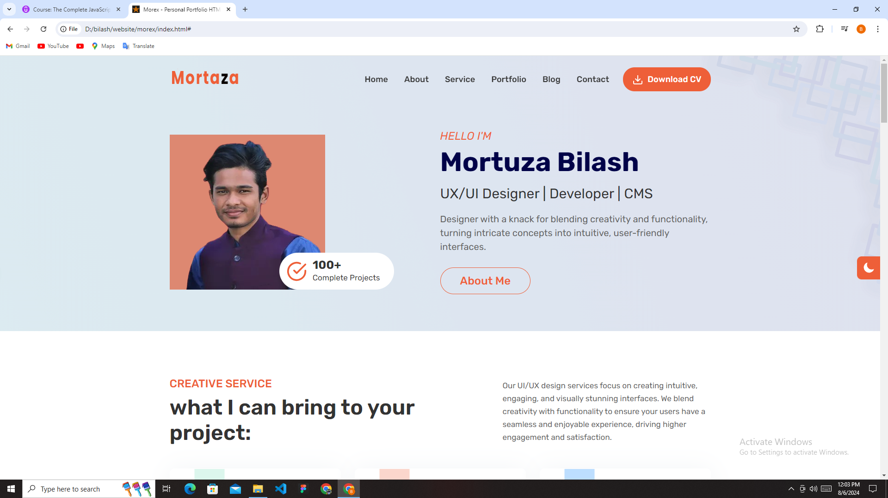

1. Work on about me button. When I click this button, About Me section will appear.
2. In navigation section Blog, Contact, and Download CV is no longer needed.
3. Please take a look at all description, button, all image and fix it if need be.

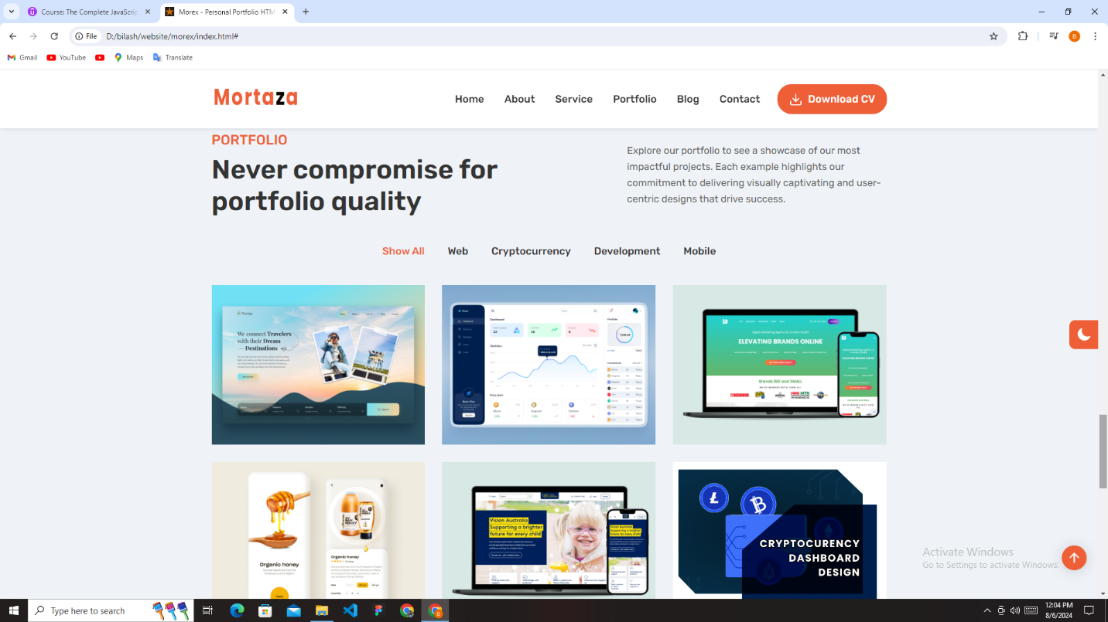

1. Please revise what will be the portfolio item Title, and which item will be place in under which title
2. For resource please check file name portfolio.

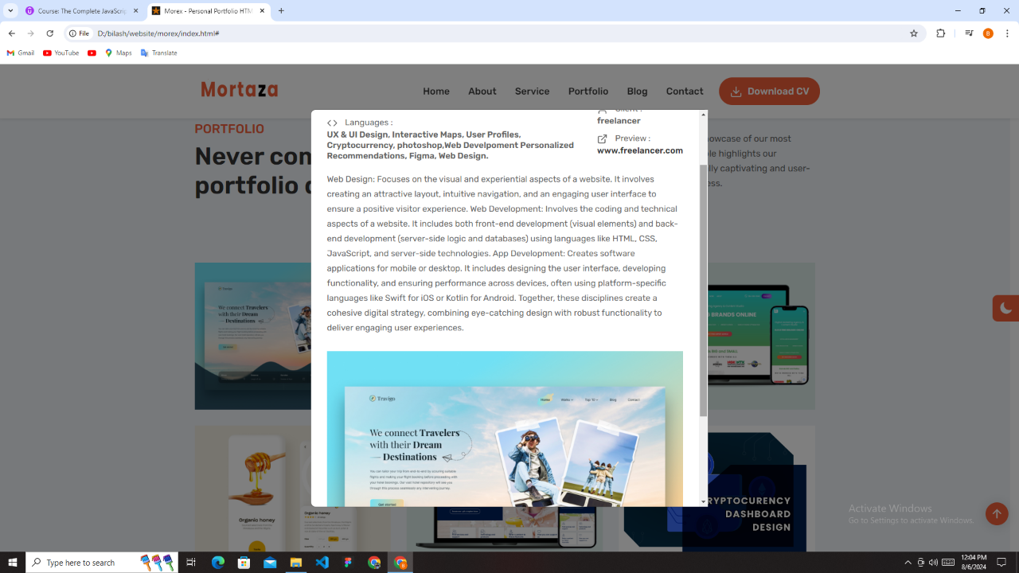

1. Please replace the description for all portfolio item.
2. For resource please check file name portfolio.